Reading Male Voice Choir.

Minutes of the Annual General Meeting held on Friday 4th July 2025 at 7.30pm.

- Welcome
John kay, (Chairman) welcomed everyone to the meeting and confirmed that all paperwork had been sent out to the members.
Present.
Ryland Lee, Steve Richardson, Bob Hill, Geoffrey Million, Dennis Bryant, Derek Reigate, Jim Grufferty, Steve Andrewes, Jeremy Jones, Chris Bintcliffe, Chris Carr, Frank Neale, Colin Hinks, David Paine, Dave Allen, John Carr, Peter Woodward, Paul Lyden, John Kay, Clive Waterman, Alan Crisp, Dave Brownhill, Geoff Gale, , Bob Castelign, Paul Champion, Geoff Crabb, Jon Saverton, Mike Jearey, Robin John, Simon Walker, Martin Butler, David Adby, Paul Moir, Tony Dunne, Nigel Shaw, John Painter, John Adams, Ken Lunnon, Roy Mantel, Arnie Howell, Ray Little, Tim Small, Tony Rawlings, David Pomeroy, John Kay, Robin Christian, Andrew Evans, Dave Moon, Christopher Peck

- Apologies for absence.
John Oversby, Hayley Tull, Kevin Boyle, Dennis Bredelet, Alan Broodbank, Mike Newman, Fred Holloway

- Agree Minutes of last meeting.
The minutes of the previous AGM, held on Friday 5th July 2024, were agreed to be a true and accurate record of the meeting. These can be viewed on the members area of the Choir website

The Chairman advised the members that Thomas Parkes, who last year won the Junior Section of the Young Singers Competition, has reached the Semi-Final of the BBC Choir of the Year Competition. His mother mentioned to our Chairman, that she believes that his progress has been greatly improved by the support he has received from RMVC.

- Chairman’s Report
READING MALE VOICE CHOIR
Chairman’s Report to the Annual General Meeting
4th July 2025

It is a privilege to present my first report as Chairman of the Reading Male Voice Choir and to reflect on what has been another highly successful and rewarding year for our choir. Over the past twelve months, your committee has been busy, and we have continued to enhance our musical reputation, extend our outreach into the community, and maintain our longstanding commitment to charitable support. I am proud of the progress we have made and optimistic about the opportunities that lie ahead. Even before this season started, the committee were working on identifying what our key focus areas should be – we recognised that RMVC has many strengths and faced several challenges. Following this analysis, the committee decided to focus on the following:

- Recruitment and Retention
- Community Engagement
- Marketing and Technology
- Innovation (including our Repertoire)

These 4 areas have defined much of the management activity this year.

Sustaining Our Purpose
While we have seen a modest reduction in membership numbers, our resolve remains strong. We continue to deliver high-quality performances, delight our audiences, and support worthy causes. However, our committee recognises the importance of addressing this trend. A renewed focus on recruiting new singing talent will be an essential priority for the coming year.

Cornwall Tour – A Musical and Charitable Triumph
A particular highlight of the season was our four-day tour of Cornwall, where we had the pleasure of performing alongside the City of Truro Male Choir and the Mevagissey Male Choir. These joint concerts not only showcased the enduring power of male choral singing but also raised significant funds for local charities. The camaraderie and musical synergy were palpable and reminded us all of the joy and impact of shared performance.

Cultural Champion of Reading Award
We were honoured to be named Cultural Champion of Reading in recognition of our contribution to the cultural and charitable life of the town over the past 50 years. This accolade is a tribute to the efforts and dedication of every member – past and present – who has played a role in building the choir’s outstanding reputation at home and abroad.

Gwyn Arch Young Singers Competition
The Gwyn Arch Young Singers Competition has now become a firmly established fixture in our calendar. This initiative, in honour of our founder, continues to provide a valuable platform for young vocalists, nurturing future talent and promoting the joy of singing among the next generation. We are proud to be investing in youth and the development of singing talent.

Building Stronger Community Links
We have strengthened our ties with the Berkshire Music Trust, a partnership that promises new collaborative opportunities and greater visibility within the regional music scene.
Engagements of this nature will be essential in securing RMVC’s relevance and success in the years to come.

Supporting Charitable Causes
Through our performances and events, the choir has helped raise over £10,000 for local charities this season. This remarkable achievement reflects the dedication of our organisers, the generosity of our audiences, and the core values that underpin everything we do. Thank you to all who have contributed to this success.

Musical Advisory Team
The establishment of a Musical Advisory Team this year has added a valuable new dimension to our musical development. By encouraging member input and closer collaboration with our Musical Director, we have enhanced our repertoire and raised performance standards. This initiative is already having a positive impact and will continue to play a vital role going forward.

Looking Ahead to Season 2025/26
Thanks to the excellent work of our Concert Secretary, we have another full and exciting programme planned for the year ahead. Martin Butler will report on these, but notable performances are our upcoming concert with the Mevagissey Male Choir in September, and the third Gwyn Arch Young Singers Competition scheduled for 2026. I encourage you all to get involved and help make these events a resounding success.

Recognising Long Service
It is always a pleasure to honour those who have dedicated many years to RMVC. This season, we celebrate the following milestones:

- 10 years: Martin Deaves, Paul Moir
- 20 years: George French
- 30 years: David Pomeroy
- 40 years: Geoffrey Million
- 50 years: Alan Broodbank
Our warmest congratulations and sincere thanks to each of these members for their dedication, commitment and loyalty.

Acknowledgements
RMVC thrives because of the dedication, generosity, and hard work of many individuals. I would like to express heartfelt thanks to:

- Clive Waterman and Hayley Tull, our Musical Director and Accompanist, for their professionalism, patience, and inspiration.
- Ryland Lee, our engaging compère and leader of the Young Singers programme.
- Sandy Gale, Sue Bryant, Kate Crabb, and the Supporters Group for always being there with their unwavering support and encouragement.
- Mary Mantel, our official photographer.
- ‘Sav’ Saverton, for his enthusiastic running of the weekly raffle.
- The editorial team, for producing The Voice, and Ray Little for his excellent press releases.
- The few regular ‘volunteers’ who set out chairs, sound system, keyboard etc. before
each rehearsal.
- The Committee, whose tireless work has made this season a success. In particular, Martin Butler for leading the Cornwall tour, Steve Richardson for his weekly updates and administrative oversight, Mike Jearey for sound financial management, and all Section Leaders for their support and guidance.
- Our Officers, who manage our stage presence, safety, wardrobe, music, and online presence – all essential for our operations.
- Derek Reigate and Chris Bintcliffe, for keeping us refreshed with tea, coffee and biscuits each week
- John Carr, for his support and counsel throughout this season

Finally, thank you to every member of RMVC. Your commitment, spirit, and fellowship are what make this choir such a special and enduring community. Together, we continue to make a meaningful difference – musically, socially, and charitably.

With best wishes for another successful year ahead. Keep Singing!!
John
John Kay
Chairman
Reading Male Voice Choir 4th July 2025

- Musical Director’s report.

The past season has been a full, and at times taxing one, to which we have all had to respond positively in order to meet the demands of the variety of events and concerts in which we have been involved. It has also been a season that has seen us all age a little more together, with all the accompanying features that increased age brings - demands on energy, matters of health and fitness, the need for sensitivity and caring attitudes towards each other and the ever-changing needs of our dedicated choristers. The thoughtfulness and caring nature of every member of our choir is one if its greatest assets – something that outsiders notice and comment upon frequently.

Our membership may have fallen a little in recent months – something that the Committee is aware of, and I have no doubt will seek to rectify, but the dedication and commitment has certainly not! Members are always supportive of all the activities in which we become involved, and this positive attitude is what drives us forward, and enables us to meet all the challenges that come our way. This doesn’t go unnoticed, and I personally thank you all for the unstinting commitment you give.

New members continue to drift into the ranks and swiftly make positive contributions. I know that the Committee would like a few more to join for the coming season, so if you have friends or associates who just might consider being part of our team, do encourage them to come along and give the choir a try. Hopefully we may capture one or two more when we are out singing in the Butts Centre event later in December! We are not hugely judgemental – I always find that when folk begin with interest and enthusiasm, musicality develops naturally. I know that our Committee, and indeed all the members of the choir to be the envy of others with which I am associated. Dedication to the choir and the support choristers offer is very evident in both rehearsals and concerts. This support is continued in such a variety of ways, many of which we might not see, but come to realise as time passes.

With me now sending out feedback at regular intervals, and after every concert, my AGM report is now a general overview on the season now past. I personally feel that swift feedback is always more beneficial.

This is the moment when I put my head above the parapet to thank folk who do so much for us throughout the year. The trouble is that there are so many to thank that I know I risk missing folk. If you turn out to be one of those, please accept my apology now. I truly appreciate all that is done for the choir, and indeed for me personally. You all get 10 out of 10 for team effort, dedication and commitment and support for each other. Having said all that, can I thank the two Johns (chairfolk) and indeed the whole RMVC Committee and section leaders for all the effort they make on our behalf. To Martin for the tremendous effort he makes achieving concerts and events that keep us all on our toes and in the public eye. He seems to know all the right people and has the unfailing knack of being in the right place, at the right time, in order to liaise with the right people. To Mike who manages our finances with great skill; Derek and Chris who make our coffee each week not to mention a wide variety of biscuits – some rather stick of late. Sav who manages the raffle and social events; Steve R and Andrew who with Chris C, Ozzie and others do so much behind the scenes, as does Chris Carr on the technical front. Then there is Nigel who does his best to keep us in order at concerts, Kevin who I pester regularly regarding music, Geoff who sticks things on my ears at the start of each rehearsal to assist communication, Chris P who keeps a wary eye on all of us, and especially me when I jump on or off my staging block. Then there is Steve A who has the unenviable job of scribbling down notes at our meetings and Robin who is in charge of jackets and the anvil!, Allan Crisp who adds the drum to our Kenyan music. Then there are all the chaps that take on solo parts in songs that demand such contributions. It takes a good deal of courage to sing the solo or group parts in songs. To all who contribute – my grateful thanks! That’s not who whole list, I’m just having a break!

There are a group of folks to whom I offer special and personal thanks – Tony D & Tony R who with Tim, and others, ensure that my equipment is ready and waiting at the start of rehearsals, and put away when all is done. These folk are particularly valuable to me and greatly appreciated. Tim and teams of RMVC also take control of the staging installation for concerts which, of course also requires the hiring and use of a van each time. We are indeed lucky to have such capable and willing folk.
Then of course we have Ryland who comes into his own at every concert, and indeed other events too. Next season will see him initiate the third ‘Young Singers’ competition – preparations for which have begun already.

Of course there is my right-hand woman and master [mistress] of the keyboard, Hayley, without whom I could not function as I do. I know that she has had a demanding year yet never ceases to amaze me with her professional skill, expertise and sensitivity. It must have something to do with that coffee!

New learning has been achieved at good speed, ably supported by choristers who set down recordings of parts for their group so that these can be listened to and practiced. ‘Noteworthy’ is also another useful resource - my thanks to all those in charge of that. We are currently tackling a wide range of genre which allows me to change programmes to better suit the venue and audience. We have tackled, and achieved pieces that are very demanding, something that can only be achieved with the effort and support of all choristers. We have all been tested at times, but the results of that effort are now there for all to see.

Really tricky songs such as Dana Dana, Swansea Town, Last of the Summer wine are now up to performance standard thanks to everyone’s concerted efforts. Being able to sing some items in a very spread position is doing a lot for chorister confidence too, and the production of a good, blended sound that stays in pitch!

There will never be another Seb, and it has taken me some time to revisit the Benedictus from the Armed Man that Seb, even in his advanced years, had made his own. We shall bring this back next term as a tribute to him, as well as the fact that we all thoroughly enjoy Carl Jenkins wonderful music.

Our recent trip to Cornwall was a great experience, and truly worth the effort. The great plus to trips is that we all get time to really chat to each other. The social benefits can be just as important as we have time to engage with each other, sing together, and cement friendships. These adventures don’t just ‘happen’ without everyone’s co-operation. My thanks to everyone for making this trip a season highlight.

As the last concert of the season with the Downley Voices has only just taken place I have not been able to comment on it till now. This was a new venue for us, and it proved to be a very good one. My broken finger encouraged me into making several changes to the programme all of which seemed beneficial. The evening was a most enjoyable one and RMVC sang particularly well. We sang Carricfergus while surrounding the audience and the lovely building helped to produce a magical sound on which many commented. My thanks to Bill for bringing helping to facilitate this concert, which just happened to be the swansong of their current conductor. It was a super way to end our season.

The Choir being voted Champions for Reading 2024 in a culture contest organised by ‘What’s On Reading’, came out of the blue. The recognition and resulting publicity can only be good for the Choir. Well done all, and thanks to all who may have helped RMVC to achieve this award!

Our recent participation in BYMT events is also proving positive. Strengthening those links can open up opportunities on many fronts. Ryland did good work promoting next year’s ‘Young Singers Competition’ many boys at these events were certainly interested. I shall be interested to see if any who were there take up the chance to participate. There is much untapped talent in our area!

Well, that is enough from me. Enjoy your well-earned break and keep well! I look forward to seeing you in September ready to take on the challenges of the coming season. May our great team continue to go from strength to strength.

The RMVC is a great choir, and it is a privilege for me to lead you!

My best wishes to you all! Clive – your MD

- Secretary’s Report
The majority of my role as Secretary is to communicate. I do this by sending out the choir updates, passing on the various messages sent to me for dissemination, as well as writing and sending the choir newsletter. This newsletter is sent to ex-members and others who have expressed a wish to be kept informed about what we’re doing, this goes to approximately 60 recipients.

Feedback from the updates is virtually non-existent; I take this as a positive as you are far more likely to contact me about them if something is wrong. Feedback from the newsletter is far more positive, I regularly receive thanks for letting people know how we are doing.

During this season I have sent out many updates to you all as well as four newsletters, and I’ll be sending another when this season is over.

I also receive emails for the choir. Some of these are informative and I include them in the updates whereas others are less so. I have lost count of the number of organisations who want to: reduce our rates through appeal (we don’t pay rates), cut our energy costs (we don’t have any energy cost), offer to help our CEO with strategy (our Chairman does a good job for us), or offer to help with our website (Andrew does a fine job here). Needless to say, the Secretary email account has a large ‘deleted’ section.

As Secretary I am also one of the Choir Trustees and, along with the other Trustees, have legal responsibility for what we do; this is a requirement due to our status as a Registered Charity. The Trustees meet regularly to make decisions and other Choir Officers attend as well to express their views.

Steve Richardson

- Concert Secretary Report

Concert Secretary Report - AGM 4th July 2025
2024/2025 season follow up
Another busy season Concerts together raising over £10k for local charities/churches
Kaleidoscopic UK £903
RNLI £3568
Reading Minster £2393 (Christmas Concert)
Parkinson's UK – Reading £1700
St Mary's Purley £810
Royal Berks Charity £780
Thames Hospice ------
TOTAL £10,154

Apart from these concerts RMVC also sang with Crosfields school as part of their celebrations of singing for all ages.

RMVC also had a successful visit to Cornwall and sand with from Truro Male choir and Mevagissey Male Choir in 2 seperate concerts helping to raise funds for local Charities.

For the first time in a very long time sang at a wedding (Elle Stevens who has sung with RMVC many times and hopefully will be again soon) and also worked closely with Berkshire Maestro's in promotion of singing of the male voice at all ages which concludes the season with a concert at the Hexagon which RMVC will also take part in.

2025 /2026 Season

Saturday 27th September 2025 7.30pm
Venue St Edmund Champion Church, 40 Altwood rd, Maidenhead, SL6 4PY. Mevagissey Male Choir will be in Reading for Concert with RMVC as guest choir. Afterglow will follow in the school hall. Raising funds for the Church chosen charities

Saturday 1st November 2025 7.00pm
Venue St John the Evangelist Church, St John's Road, Newbury, RG14 7PY. Charity for Parkinson's Newbury. Support act - Sing for Fun Choir

Saturday 6th December 2025 afternoon and evening
- Singing for the public at Broad Street Mall 2pm – 3pm
- 4pm Arrive at Salvation Army placement rehearsal followed by afternoon tea
- 6pm to sing at Salvation Army Christmas concert in Reading

Saturday 20th December 2025 5.00pm
Christmas candlelit concert at Reading Minster with Occasions singers raising funds for Reading Minster
Saturday 7th February 2026 7.00pm
Christ Church Woodley – Concert for Charity Parkinson's Reading they have requested Time to Sing Choir to be guests again

Saturday 7th March 2026 7.00pm
Venue – TBC ( in Wokingham) – Concert for Charity Kaleidoscopic UK. support TBC

Saturday 28th March 2026 All Day
Abbey School – Young Singers Competition Help required all day from men and ladies

Saturday 25th April 2026 7.00pm
Venue TBC (in Oxford) Concert for Charity Parkinson's Oxford support TBC

Saturday 6th June 2026 7.00pm
Sindlesham Court, Mole Rd, Sindlesham. – in the Temple For Masonic centre members + would like a single solo singers to support.

Saturday 27th June 2026 7.00pm
Abbey School - Gala concert for Young Singers

2026 /2027 Season

Saturday 26th September 2026 7.00pm
Joint concert with BUILTH male voice choir, venue TBC

Possible trip abroad in 2027

I am currently in discussions with Donaghabee Male Voice choir. They are in a small town in County Down on the north east coast of the Ards Peninsula in Northern Ireland 19 miles (45 mins) from Belfast. Bangor is just 6 miles away.
Donaghabee is 29 miles (56 mins) from Carrickfergus which itself is 12 miles (28mins) from Belfast.
Looking to fly from Heathrow to Belfast and a hotel on outskirts of Belfast giving easy access to both Donaghabee and Carrickfergus. Bangor also host an annual music festival each April which I will explore info on.
Donaghabee Male Voice Choir have about 50+ aging members, just holding their AGM and new committee coming back to me in July

Other ideas for 2027

Another option is to do a day trip locally by coach, ie Bournemouth/Brighton etc.... somewhere only a couple of hours drive away and make a day of it.

MB added the following to his report:
The money raised from the recent Thames Hospice Concert amounted to £531, bringing the annual total to £10,685 over the 7 concerts. This does not include the non-profit concert for Crosfields School. In addition, a further concert was cancelled and is now rebooked for this season. We also performed at 2 concerts with Truro and Mevagissey Male Choirs.

For next season we have 9 concerts booked, with the March Concert now taking place at Finchhampstead Baptist Church, along with A Capella Group, AVENUE, who have supported us in the past. In addition, we have the return visit of Mevagissey Male Voice Choir in September. These events, together with the 2026 Young Singers Competition provide us with anther full year.

In 2027 Builth Male Voice Choir are also planning a return visit.

Future trips will be planned biannually beginning in 2027. MB is currently in contact with Donaghabee Choir from Carrickfergus, in respect of a possible visit to Northern Ireland

- Treasurer’s report

- Annual Report and Accounts for the year 2024/5
- Budget for the Year to 231st May 2026
- Honoraria
- Subscriptions
- Motion to adopt the Treasurers Report
Choir Funds
Summary of the choir’s finances for the period 1st June 2024 to 31st May 2025.

Balance at: | 31 May 24 | 31 May 25 | 31 May 26
 | Actual | Actual | Projected*
Account: | £ | £ | £
Assets | 18 | 18 | 18
Debtors | - | - | -
Metro Bank Current Account | 7,241 | 6,613 | 6,613
Metro Bank Reserve Account | 17,755 | 17,927 | 17,386
Metro Bank Tours & Events Account | 14 | - | -
Cash and cheques | - | 18 | -
Creditors | - | -
TOTAL | 25,028 | 24,576 | 24,000
RESERVES (net current assets) | 25,010 | 24,558 | 23,982
Notes:
Discretionary Funds are net current assets less reserves (our target increased to £17,500 from 2022). Core income are subscriptions, tuition fees, tax refunds, weekly raffle
Core support costs are MDs’ honoraria, hire of rehearsal hall, music
Core management/administration includes Trustees’ expenses, insurance Financial reporting & budgeting is calculated on a Cash Basis.

The balances as at the end of May 2024 are as in the Annual Report and Accounts. Reserves are as defined by the Charities Commission. They are represented in our accounts by the subtotal Net Current Assets.
Since we have written down our fixed assets to nominal values, in most years our total balances only slightly exceed our reserves.
The Committee retains the following items agreed in previous years:
- In November 2022, the Committee agreed to our long-term Reserves target to £17,500.
- The Committee agreed to set aside £2,500 ‘protected funds’ to ensure the continuation of the Gwyn Arch Young Singers competition in future years.
Tours and Event Account
This account was opened in previous years to help separate revenue and costs for tours, such as the tour to Cornwall in April 2025 and events such as the annual Christmas party, from the revenue and costs incurred in the choir’s delivery of our charitable purpose and activities.
We found the existence of two accounts to be confusing for members when deciding which of the choir’s accounts to deposit funds into and the additional bank charges and administration effort this caused, further reduced the benefit.
The Tours and Event account has now been closed.
All tour and event income and costs will continue to be recorded in the financial accounts system and the net income or expenditure included in the charity’s financial reporting.

Income And Expenditure 2024 - 2025
See detailed Statement of the choir’s financial activities for the 12 months to 31 May 2025 attached below.
Our reportable income for the period was £17,850.
The Choir’s charitable activities (7 ‘regular’ concerts and some “in-formals”) raised £4,401 over the year.
Our concerts raised over £10,000 for the charities using our performances as fund raisers.
There were 62 paying members (and one Life Member) at the end of the choir year, generating a combined subscription/tuition fee income of £8,771.
Other income including Gift Aid, the weekly raffle and Reading Community Lottery added a further £4,678.
Our reportable expenditure for the year was £18,302.
- Core Income £11,488,
- Core Expenditure £14,688
- Net Core Expenditure £3,200
- Net Non-Core Income £2,749
Expenditure exceeded income by £452, compared to a balance of income and expenditure in the budget approved by the AGM in July last year.
Our accounts were inspected and approved by our independent examiner on 16 June 2025.

Income Analysis
- Funds Generated: £286 below budget
  - Membership subscriptions and related income (Tuition Fees and Gift Aid Refund, Raffle) were below budget, offset by sponsorship and donations were
£450 above budget
- Income from Choir Activities: £524 Below Budget
  - Income from concert fees, and sales of tickets, programmes and CD was below budget, offset by a net contribution of £208 from social events
- Sundry Income was £734 over budget, mainly due to increased support by members of the from the Reading Community Lottery.

Expenditure Analysis
- Costs of Fundraising: £109 less than budget
  - Publicity costs were less than anticipated
- Costs of Choir Activities: £1,180 more than budget
  - Concert Expenses above budget mainly due to expenses (£778) for the Gwyn Arch Young Singers Competition auditions and gala concert in July 2024
- Support Costs: £1,296 less than budget
  - Anticipated costs of hiring rehearsal halls, Uniforms and equipment & transport were less than expected.
- Management & Administration Costs: £601 more than budget
  - Main impacts:
▪ Purchase of new long-service awards (Pins and Tankards) - £710
▪ Doubling of insurance costs (from £151 in 2024 to £337 in 2025)
▪ One off- purchase of an accounting software licence (£150.00)
- Gwyn Arch Young Singers
  - Expenditure of £600 in this budget line reflects the value of the winner’s prizes only.
  - Total expenditure of £1,656 on the competition was offset by income of £1,321, with a net cost of £334 in the 2024-25 choir financial year.

Financial Plan 2025-2026
I propose to continue the strategy of carefully reducing our Reserves towards the target set by the committee whilst sustaining the choir’s financial operating model.
The budget recommended by the Committee for the choir year 2025-26 will encourage us to continue to maintain the tempo and quality of the choir’s activities, while tolerating slightly less income.
Membership subscriptions are the one income source that is not countered by operating costs or constrained by the number of concerts we can perform. A targeted recruitment effort would both improve our financial position and improve the sustainability of the Choir.
I expect upward pressure on Core Expenditure and other costs to continue in the coming year. CPI over the past 2 years has generally remained above 3%, compared to levels generally below 2% that was the previous norm.
This means that, while the Committee has recommended a balanced budget, the risk is towards increased expenditure so we may reduce our reserves by June 2026
The recommended budget is attached, and is based on these assumptions:
- As in the 2024-25 choir year, we will deliver 7 fee paying concerts at a fee of £400, except the Christmas concert at the Minster where I have assumed £350 as our ‘share’ of the fee. We will also perform at a few “in-formal” concerts that will raise some income as well as the YSC Gala Concert.
- While I expect concert costs, including transport of staging, to rise, I propose to keep our concert fee at £400.00. This will reduce the return on concerts but will increase the value to the charities for which we perform, one of our charitable aims.
- Gwyn Arch Young Singers Competition:
  - I have a preliminary budget (to be confirmed by Committee) showing a net cost of £1,260 (£2,890 costs, £1,630 income) for the 2026 Competition.
  - The 2025-26 budget assumes YSC costs of £1,400.00, 50% to be covered as a “draw-down” from reserves, the rest funded from our current funds.
  - Most of the YSC income and remaining costs will fall into the 2026-27 accounts.
  - This excludes any sponsorship we may obtain.
- Choir Membership:
  - We have 62 subscription members and one honorary member in the choir at the end of the year. We had a net loss of 1 member (2 joined, 3 left)
  - Our membership count is unchanged over the coming, and we target increased recruitment in the coming year.
- We continue to receive funds from the Reading Community Lottery at the same rate (set by member’s continued support).
- Membership Subscriptions:
  - Increase by 4% to £153.00, including £20 tuition fee
- MDs Honoraria:
  - Increase by 4%.
- We will balance the costs of any social events against contributions.
- No tours are planned in the 25-26 choir year.
- We are hosting a visit by Mevagissey Male Voice Choir, in September 2025 and will endeavour to balance any social event costs with income.
This budget will balance our income with expenditure. Core expenditure would be £2,534, offset by net non-core income of £2,534.
Our Reserves (drawing down £700 of the Gwyn Arch Young Singers Competition allocation) will reduce to below £24K.

Budget Discussion
In recommending the budget for approval in the AGM, the Committee looked at some alternative scenarios and assumption before agreeing on this recommendation as realistic and achievable.

Independent Examiner of Accounts
This is the fifth year that Sukey Joshi has examined our accounts and Sukey has indicated that she would be happy to continue in this role should the AGM approve her appointment for the current year.

Decisions Required by AGM
On the recommendation of the Committee, the AGM is requested to approve the following decisions:
- The adoption of the Trustees’ Annual Report and Receipts and Payments Accounts (CC16a) for the year ending 31st May 2025 (see separate attachments)
- The budget recommended by the Trustees and Committee for the year ending 31st May 2026 (see attached)
- The MD Honoraria recommended by the Trustees and Committee for the year ending 31st May 2026 be increased to £5,380 p.a. for the MD and £4,601 p.a. for the Accompanist
- The subscriptions, including Tuition Fees, for the year ending 31st May 2026 increase to £153.00.
- The adoption of this Treasurer’s Report.
- The appointment of Ms Sukey Joshi as the Choir’s Independent Examiner of Accounts for the year 2025/26
Proposed: Treasurer Seconded: Chairman

Mike Jearey John Kay
4th July 2025

Statement of Financial Activities for the year to 31 May 2025
Recommended Budget: Year to 31 May 2026

 |  | 2024/5 | 2024/25 |  | 2025/26
 |  | Approved Budget | Actual |  | Recommended
 |  | £ £ | £ £ |  | £ £
INCOME |  | Inc Exp | Inc Exp | Var | Inc Exp Notes/Assumptions
Funds Generated
f1 Members' subscriptions |  | 7,954 | 7,571 | -383 | 8,025
f6 Members' tuition fees |  | 1,240 | 1,200 | -40 | 1,264
f2 Tax refunds on Gift Aid |  | 1,830 | 1,867 | 37 | 1,858 Assume 20% of Subs
f3 Weekly choir raffle |  | 1,200 | 850 | -350 | 850
f4 Sponsorship |  | 0 | 400 | 400 | 200
f5 Donations, legacies |  | 100 | 150 | 50 | 150
Subtotal: Funds Generated |  | 12,324 | 12,038 | -286 | 12,347
Income from Choir Activities
c1 Concert fees |  | 2,800 | 2,504 | -296 | 2,500
c2 Sales: concert tickets |  | 1,850 | 1,406 | -444 | 1,450
c3 Sales: programmes |  | 175 | 338 | 163 | 340
c4 Sales: CDs, tapes |  | 100 | 46 | -54 | 50
c5 Concert tours and events |  | 0 | 0 | 0 | 0 No tour in 2025/6
c6 Social events |  | 0 | 208 | 208 | 0 Balance social events
c7 Refreshments (net) |  | 0 | -100 | -100 | 0
Subtotal: Income from Choir Activities |  | 4,925 | 4,401 | -524 | 4,340
Other Income
i1 Bank &c interest |  | 150 | 161 | 11 | 160
i2 Contributions: uniform |  | 0 | 0 | 0 | 0
i9 Sundry income |  | 528 | 1,251 | 723 | 1,250 Maintain RCL income
Subtotal: Other Income |  | 678 | 1,412 | 734 | 1,410
EXPENDITURE
Cost of Generating Funds
g1 Fundraising, publicity |  | 520 | 411 | -109 | 450
Subtotal: Cost Of Generating Funds |  | 520 | 411 | -109 | 450
Cost of Choir Activities
d1 Concert expenses |  | 300 | 1,409 | 1,109 | 1,070 Incl. £250 for BMT Concert, '24 Costs include  £600 YSC
d2 Producing programmes |  | 140 | 205 | 65 | 216
d3 Travel, accommodation |  | 0 | 6 | 6 | - No tour in 2025/26
d4 Recordings |  | 0 | 0 | 0 | -
d5 Social events |  | 0 | 0 | 0 | 100 Refreshments AGM
Subtotal: Cost of Choir Activities |  | 440 | 1,620 | 1,180 | 1,386
Support Costs
s1 Musical Directors |  | 9,597 | 9,597 | 0 | 9,981 4%
s2 Hire of rehearsal hall |  | 3,500 | 3,006 | -494 | 3,100
s3 Music |  | 500 | 611 | 111 | 500
s4 Uniform |  | 500 | 0 | -500 | 150
s5 Equipment, transport |  | 900 | 487 | -413 | 550
s6 Depreciation |  | 0 | 0 | 0 | 0
Subtotal: Support Costs |  | 14,997 | 13,701 | -1,296 | 14,281
Management & Administration
e1 Administration |  | 500 | 987 | 487 | 300 £710 for service pins in 24
e2 Trustees expenses |  | 100 | 150 | 50 | 100
e3 Insurance |  | 170 | 337 | 167 | 380
e9 Sundry expenses |  | 0 | 497 | 497 | 500
y1 Gwyn Arch Young Singers |  | 1,200 | 600 | -600 | 700 £1,400 total cost, 50%  from reserves
Subtotal: Management & Administratio | n | 1,970 | 2,571 | 601 | 1,980
TOTALS | 17,927 17,927 |  | 17,850 18,302 |  | 18,097 | 18,097
Net Core | 2,143 |  | 3,201 |  |  | 2,364
Net Non-Core | 2,143 |  | 2,749 |  | 2,364
NET TOTAL | 0 |  | -452 |  | -0
- 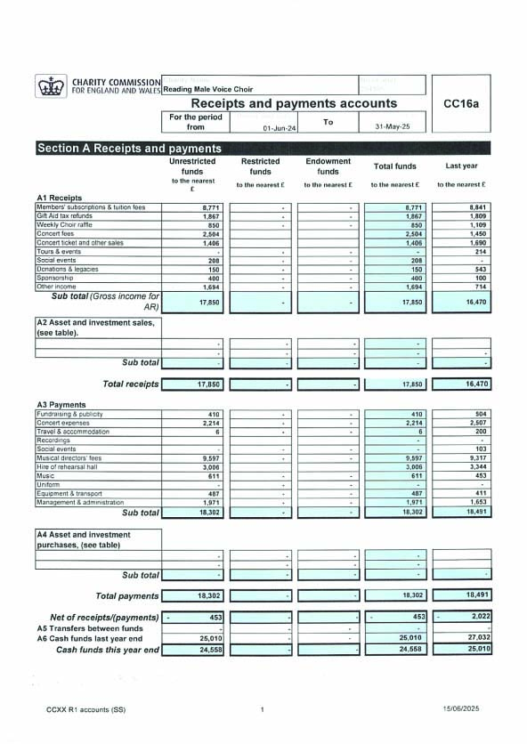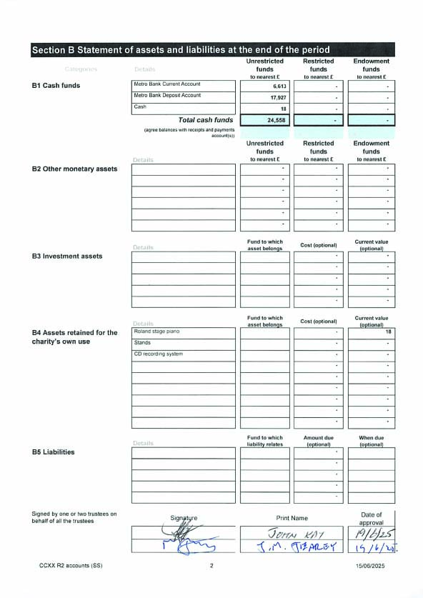
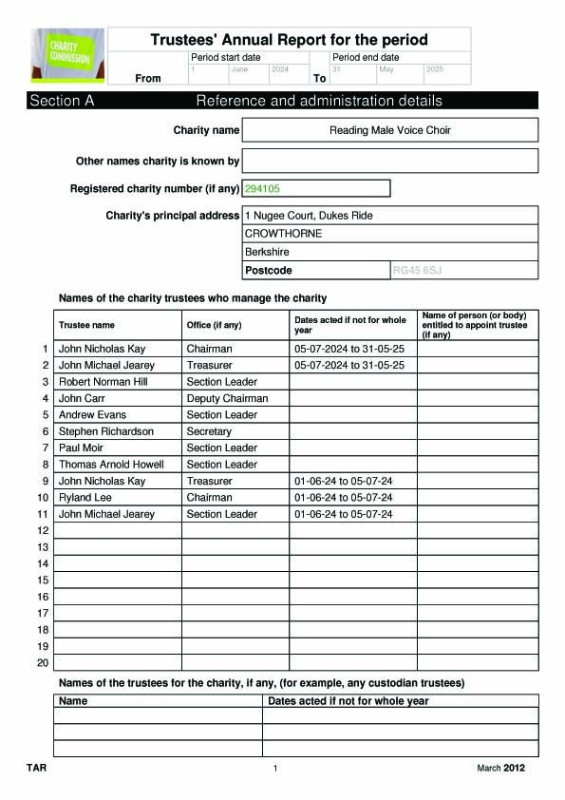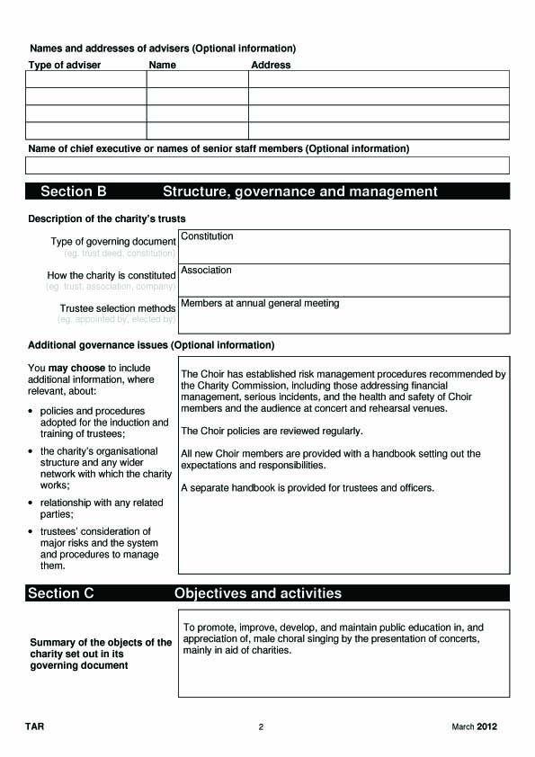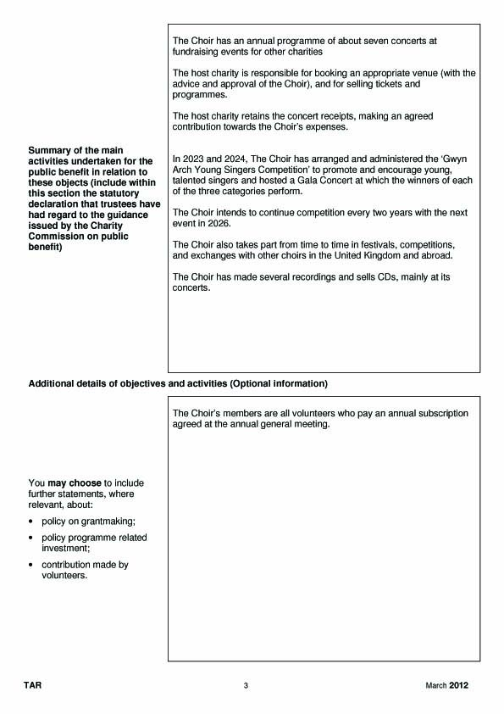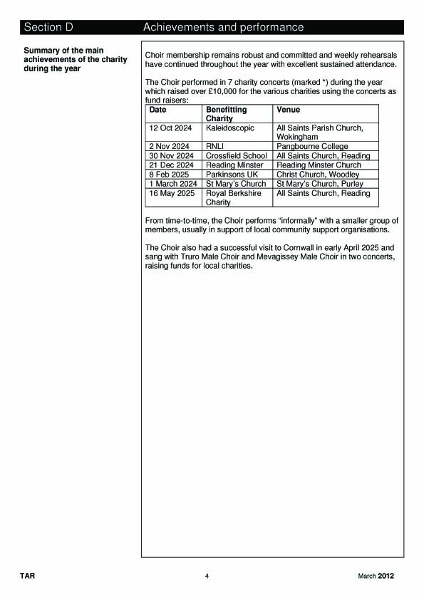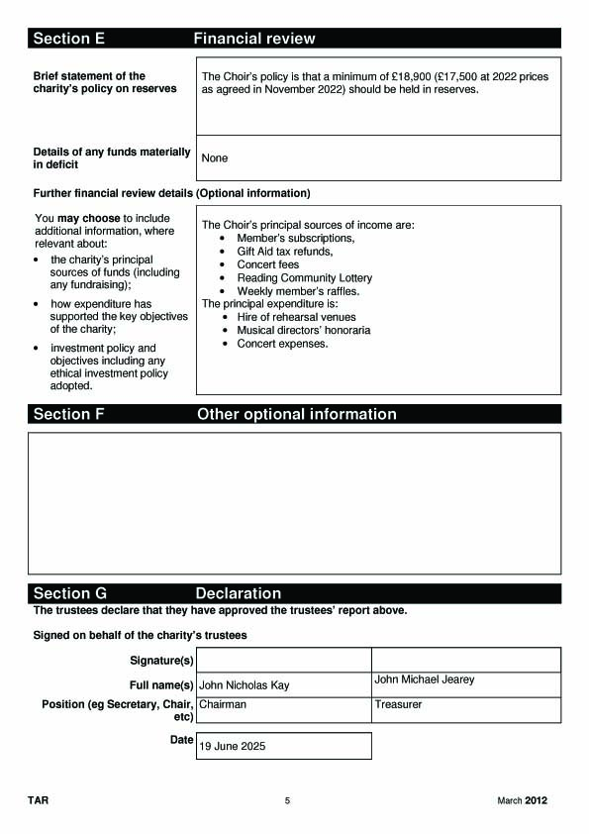
MJ confirmed that the 2024/5 Budget had been met and that increased funds from the Reading Charity Lottery and Raffle have both made a substantial contribution.

Funds passing through the accounts , e.g. Tours and Events, are not included in the figures as this would artificially inflate the figures subjecting us to further Charity Commission costs and restraints. This is a perfectly acceptable practice

The accounts have been signed off by our thorough, Independent Examiner.

MJ explained that our Reserves are currently higher than normal to allow for unforeseen events out of our control: e.g. MD being unavailable for any longer period. However, there is room to draw down on these funds if required and an example of this would be in the event of no sponsorship being obtained for the Young Singers event.
The MD was requested to leave the meeting while Honoraria were discussed.
A proposed increase of 4% in both payments to our Musical Director and Accompanist was agreed, following a discussion. JK advised that if Members were unhappy or wished to Committee to revisit these proposals in the future, non-committee members can approach via their Section leaders.

The following items were presented for approval by the Members, the Committee having previously approved them:-
Agreement of Budget and Treasurers Report – Prop GC, 2nd GG – Approved
Agreement of Honoraria and Subscriptions rises – Prop MD, 2nd GM
The Chairman expressed his thanks to MK for his work in his first year as Treasurer.

Independent Examiner’s Report to the Trustees of Reading Male Voice Choir

I report to the Trustees on my examination of the accounts of the Reading Male Voice Choir (‘the Choir’) for the year ending 31st May 2025.

Responsibilities and Basis of Report

As the charity trustees of the Choir, you are responsible for the preparation of the accounts in accordance with the requirements of the Charities Act 2011 (‘the Act’).

I report in respect of my examination of the Choir’s accounts carried out under section 145 of the 2011Act, and in carrying out my examination I have followed all the applicable Directions given by the Charity Commission under section 145(5)b of the Act.

Independent Examiner’s Statement

I have completed my examination and I confirm that no material matters have come to my attention in connection with the examination giving me cause to believe that in any material respect:

- Accounting records were not kept in respect of the Choir as required by section 130 of the Act; or
- The accounts do not accord with those records.

I have no concerns and have come across no other matters in connection with the examination to which attention should be drawn in this report to enable proper understanding of the accounts to be reached.

Sukey Joshi
16 June 2025

9. Appointment of Independent Examiner of Accounts (Rule 7d)

Appointment of Independent Examiner – Prop GM, 2nd DB – Approved

10. Annual Health & Safety Report – June 2024
RMVC Annual Health & Safety Report – June 2025
Annual maintenance:
- PAT testing of electrical equipment was completed 5 Oct 2024.
- Staging equipment inspection was completed on 5 Oct 2024. There were no concerns regarding its condition.
Fire Safety:
- Annual fire safety briefing for Hawkedon School rehearsal venue was given to Choir Members on 22 Nov 2024 and to Friends of Choir on 01 Nov 2024.
Health & Safety Documentation:
- The Health and Safety Policy and Good Practice Guides were updated in Sep 2024.
- The Health & Safety Good Practice Guide for Concerts was updated following an accident investigation and reissued on 28 Oct 2024.
- The current Health and Safety Documentation is available on the Choir website.
- All members are encouraged to read them and follow the good practice.
First Aid
- The contents of the First Aid Kit were checked in Oct 2024 and some items removed as out of date. A burns gel and some microporous tape were added. The kit now contains an up-to-date contents list.
- An annual rota was issued in Oct 2024, two first aiders are allocated to each concert. This contains information about known Defibrilators (AED) at or adjacent to each venue.
- We are ending the year with 9 trained emergency first aiders. Thankyou for their service this year.
Choir Accidents and First Aid Incidents
- The choir requires members to report any accidents or incidents that occur while at rehearsal at Hawkedon School, or setting up and performing at a concert venue.
- This year we have recorded 1 incident:
  - An incident occurred at the concert on 12 Oct 2024. A choir member came close to fainting on stage towards the end of the concert. An investigation report was prepared and circulated to the committee.
- Further actions were agreed to mitigate the chance of this happening at future concerts. The Good Practice Guide for Concerts was updated and reissued, incorporating the agreed actions.
Risk Management
- Members are asked to be alert to new hazards arising in our rehearsals and at concert venues and to bring any concerns to the attention of the Health & Safety Officer, so that they can be investigated and adjustments made as necessary.
- We now have a new cable cover to protect and reduce risk of tripping in the rehearsal hall.
- Thank you to all who have helped me through the last year.

Christopher Peck (Health & Safety Officer), 15 June 2025
CP thanked all those who assisted in checking our Kit for safety, and to the First Aiders . He also confirmed that he was happy that all relevant procedures were correct and in place, but that we needed to ensure that guidance was followed.
JK thanked CP for his report and work throughout the year.

11. Section Leaders and other Choir Officers reports.

- Section Leaders
Tenor 1
At the start of this season , when I took over as section leader, there were 16 members and Pat Connell, who we think won’t return due to ill health.
Clive Willey, who has had progressively difficult operations on his leg , has since decided to leave but will, when possible, attend our friendly coffee mornings .
So that means we have now 15 members and Pat.
Paul Champion has been absent due bereavements in his family since Easter but we hope he returns soon.
Attendance at rehearsals is on average 12 and at the major Saturday concerts 11.
There is one member who has attended all of the rehearsals and all of the Saturday concerts including going to Cornwall and that is Peter Woodward. Well done Peter for your dedication and loyalty.
I look forward to another successful season with RMVC
Tenor 2
We have a new voice this year; Alan Gates has joined us and appears to be settling in well. Welcome, Alan!
John Oversby has not been amongst us recently but feels confident he will be able to rejoin us in September, so we’re spared the terrible jokes for a little longer.
We currently have 17 members, 13 of whom attend performances, so we have sufficient man-power for now.
I have now been section leader for 3 years, which is enough for any section to have to suffer, so I’ll be handing over to a new volunteer in September, Stephen Andrews, so thanks to all for co-operating with me and thank you Andrew for taking on the job.
Baritone
The baritone section is currently 15 members. We usually field about ten singers at concerts. We have a core of strong singers but we are currently on the hunt for two or three recruits to build us back up to strength.
Special thanks to all those who serve on the committee. And to those who struggled to make it to rehearsal this year despite significant difficulties at home, and various health issues, thank you all.
Bass
Good evening everyone. Choirs benefit from a bass section that provides the foundation upon which harmonies are built. Like the deep roots of a tall tree, the basses ground us with a powerful resonant voice. We bring a sense of strength and richness to performances that only a quality bottom can provide. At the beginning of the season, we were 14 strong. Like other sections we’ve had health issues. It goes with the demographics of the choir. Last autumn Mike joined us. After a couple of months he told me that while he loved the friendship and really wanted to stay but he struggled to cope with learning our repertoire even though he’d sung in choirs for years, so he decided to leave. Apparently, we’re no longer spring chickens despite what we might think. So we end the year with the same number we started with. At least we haven’t shrunk.
Concerts. There are two concerts in this year’s season I’d like to highlight. During the rehearsal on our very first outing in Wokingham I was filled with dread. The rehearsal couldn’t have gone much worse. For example at the end of Rhythm of life one side of the choir was nearly a bar adrift from the other. How many times have we sung that song, don’t we know it by now? There’s a saying along the lines of “bad rehearsal, good concert” Thankfully there’s a lot of truth in that as everything went alright on the night.
The next memorable concert was in aid of the RNLI at the Falklands Island Memorial Chapel at Pangbourne College. Now we all know Clive routinely chastises us for not being in tune. Well, the Senior Songsters clearly aren’t hindered by intonation. I could also tell they don’t listen to their accompanist much. Did it matter? No. Did we enjoy hauling the ropes, climbing the mast and looking out to sea? Absolutely. They are great entertainers who brought fun to the venue with their performance. A very enjoyable concert with a large audience and we’ll remember it, because on that occasion in all our history we raised money for saving lives at sea.
To finish off, we know that RMVC is a great example of teamwork and camaraderie. We have fun, look after one another and enjoy what we do. Finally, I want to thank Clive and Hayley for their patience and guidance throughout the year. They make what we do possible. Here's to the bass section and the choir – may our voices continue to resonate with power and grace for years to come. Thank you.
JK expressed his thanks to all Section Leaders, particularly, to AH for his years in this role.
12. Election of Committee Members (Trustees) and Officers

As all Trustees and Officers had been proposed and seconded, and there were no other proposals, JK proposed that these be accepted by the Members.

Proposed CB, 2nd MD – Members unanimously agreed.
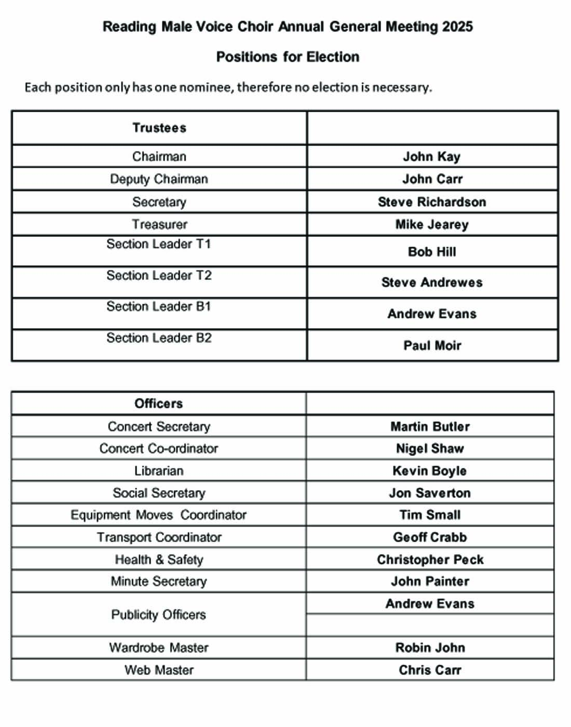

The Meeting closed at approx. 9pm

Committee meeting dates for next year (All at Hawkedon School):
11 September, 4 December, 19 March, 18 June, AGM 3rd July

